Riley Air Control Systems Pty Ltd.

SHD Series

Curtain Fire Dampers

2 & 4 Hours Fire Integrity Rating

For masonry and dry wall application

SPECIFICATION DATA

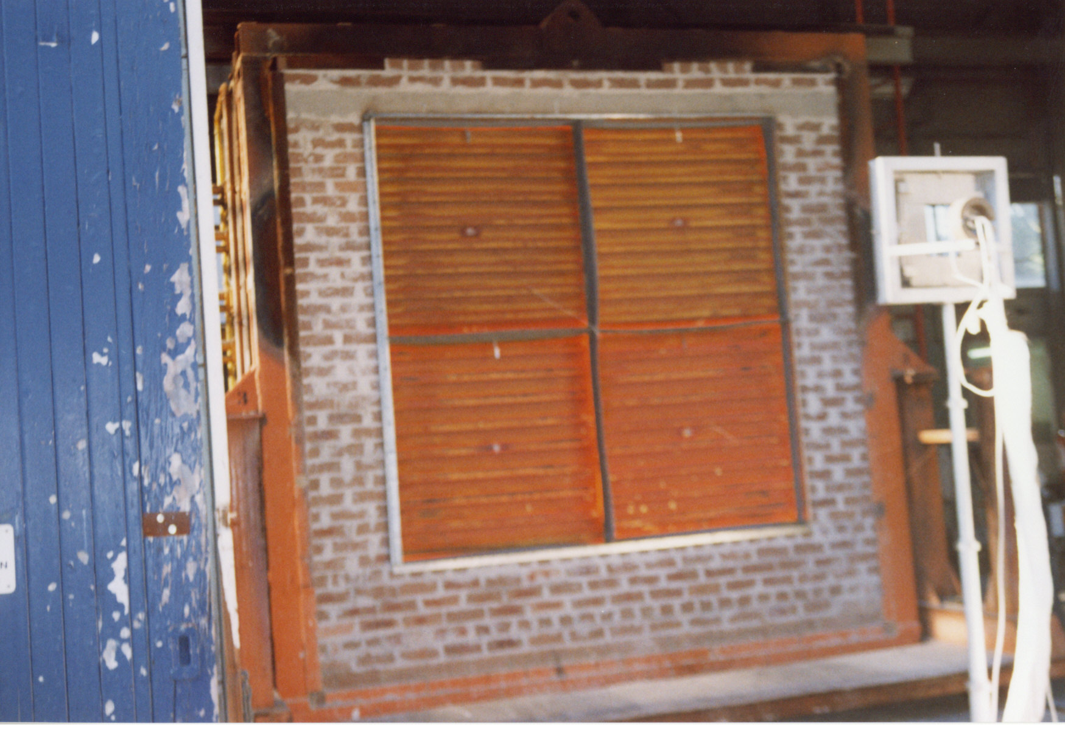

General

The Blendair CURTAIN Fire Damper Series BSHD is a simple and effective damper, designed to impede the spread of fire and/or combustible products (eg. smoke) through masonry, lightweight partition or shaft wall openings to other fire compartments of an air-handling system.

This range of Fire Dampers find it’s application in commercial building construction where ventilation, heating, cooling or air-conditioning systems are employed.

The design principle is based on an integral, interlocking stack of blades that closes by gravity to form a tightly sealed barrier when a fusible thermal link breaks at a set temperature.

Blendair CURTAIN Fire Dampers are tested to AS1530 to meet the requirements of AS1682 and ASNZ 1668. They have been tested to SS333 for closing reliability.

Features

- Simplicity in design

- Tight manufacturing tolerances

- High strength and repeatable quality of roll-formed blades

- Integral interlocking blade linkages

- Blade stack re-settable from both sides of damper

- Suitable for masonry and dry wall application

- Adjustable mounting angles

- Suitable for multi-module installation

SHD Series CURTAIN FIRE DAMPERS

DESCRIPTION
The Blendair Curtain Fire Damper Series SHD2 & SHD4 are designed to impede the spread of fire and or combustible products (e.g. smoke) to other fire compartments of an air-handling system. The design principle is based on the use of an interlocking stack of galvanised steel blades which will - by gravity - unfold and form a sealed curtain wall. A fusible thermal link, set at a specific temperature, initiates the closing of the curtain. The curtain is housed and guided in a press-formed and welded galvanised steel frame. The solid construction will ensure minimum distortion during transit, installation and operation. Adjustable mounting flanges hold the complete damper assembly securely in the wall opening, with appropriate insulating material packed into the clearance space to meet installation Standards. Curtain Dampers are certified by Standards Australia and meet AS 1682 and AS 1530 requirements.

MODELS
- SHD2: Curtain Fire Dampers for Dry Wall & Shaft Wall Application and 2 Hours Fire Integrity Rating
- SHD4: Curtain Fire Damper for Concrete or Masonry Wall application and 4 Hours Fire Integrity Rating

GUIDE SPECIFICATION (for the Engineer)
Fire Dampers installed shall be of design and construction as the SHD Series supplied by Blendair which meet the requirements of Australian Standards AS 1682 - Part 1 & 2 and AS 1530 - Part 4.

The damper frame shall be of press-formed and welded galvanised steel construction to minimise distortion during transit, installation and operation. The interlocking damper blades shall be of roll-formed galvanised steel construction to guarantee accuracy and consistent closing operation.

DAMPER SIZING SPECIFICATIONS
Modules are supplied in the following standard sizes:

Single Module: from 200mm x 200mm (min)
to 1200mm x 1200mm (max)

Size Increment: as required

Multi Modules: max size 3600mm x 3600mm

Important Notes:

1. When specifying damper sizes (width and height), quote duct size/dimensions. No deductions are made.

2. When specifying wall opening sizes to the installer/contractor, allow sufficient space for insulation and expansion, use the following formulae:

External damper size + 10 mm + 1% of linear length (width/height)

SHIPPING WEIGHTS (Kg)
Height  (mm) | 200 | 400 | Width  600 | (mm)  800 | 1000 | 1200
200 | 9 | 13 | 17 | 21 | 25 | 29
400 | 12 | 17 | 22 | 27 | 32 | 36
600 | 16 | 22 | 27 | 32 | 38 | 43
800 | 20 | 26 | 32 | 38 | 43 | 49
1000 | 24 | 30 | 36 | 43 | 49 | 56
1200 | 28 | 34 | 41 | 48 | 55 | 62
Note: For weights of Multi-Modules, add total weights by interpolating with above Weight Table.

SPECIFICATIONS - Construction

Materials & Finishes:
- Damper frame, blades and mounting angles made of zinc-coated ("galvanised") steel sheet, complying with AS 1397 with a coating class not less than Z275.

- Damage to the zinc-coating, e.g. through welding, is remedied by appropriate cleaning method and application of special 'galvanising' paint.

DAMPER ORDERING SPECIFICATION

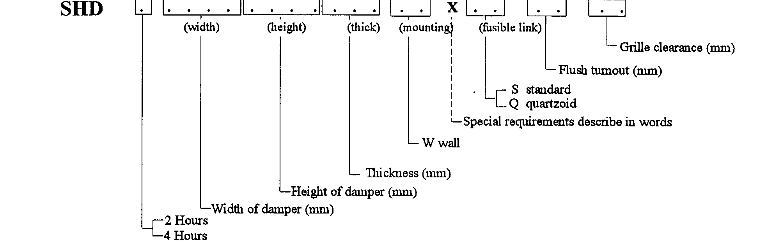

SHD Series CURTAIN FIRE DAMPERS

Damper Frame:
Press-formed 1.6 mm galvanised steel, fully welded at all four corners with 6x12 mm slots to allow for variations in wall thickness.


Damper Blades:
Roll-formed 1.0 mm (nominal) galvanised steel with special interlocking blades performing the blade pivoting function.

Blade Orientation/Location:
Horizontal: Blade stack held at top of damper by thermo-link assembly. Blade closing by gravity, initiated by thermo-link.

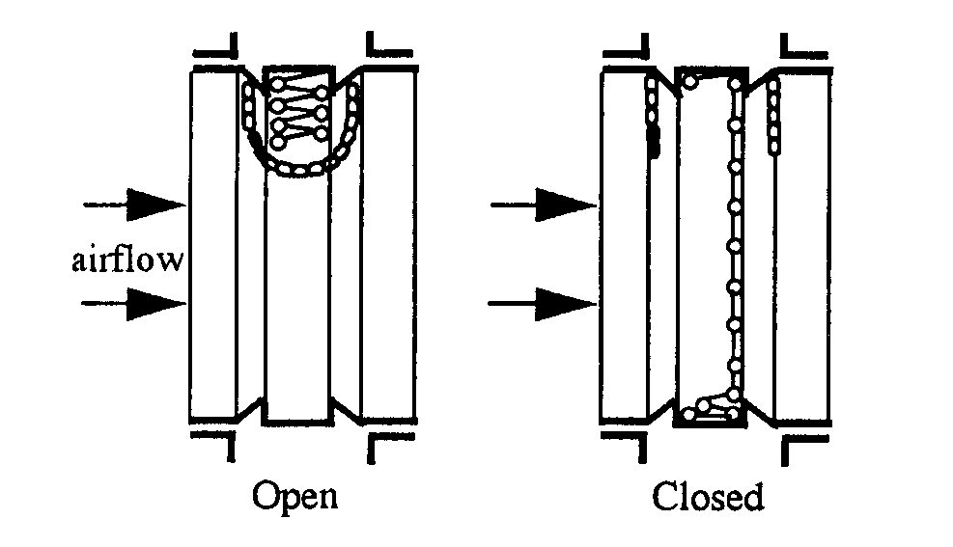

Mounting Angles:
Roll-formed 2.0 mm or 2.5 mm 'right-angle' brackets with 6x12 mm rounded slots at 150 mm pitch to allow for variations in wall thickness.

Bearings:
Blade "bearings" are roll-formed into blades, the blades interlock into each other, forming a concertina-type blade stack (curtain).

Thermo-Link:
The thermo-link is a 'once only' used link.
- Standard: Fusible Solder Link (70 degree C)
- Optional: Quarzoid Bulb (68 degree C)

Access to Thermo-Link:
From both sides of damper - for blade stack re-setting purposes or re-fitting of Thermo-Link.

Mounting Hardware:
Zinc plated 1/4 inch cup head bolts, nut and washer for each set of slotted mounting holes in frame & mounting angles.

SPECIFICATIONS - Technical

Operation:
Damper closing is initiated by the breaking of the thermal fire link, when temperature in the air stream reaches rated thermal limit. The blade stack will consequently unfold and form a curtain, impeding the spread of fire and/or combustible products to other compartments of the air-handling system.

Damper Closing Temperature:
- Standard 'Solder' Fire Link: 70 degree C (nominal)
- Quartzoid Bulb: 68 degree C (nominal)
- Special Thermal Links or Closing Actuation Devices could be fitted, providing compliance with Standards.

Maximum Air Velocity:
IMPORTANT! Curtain-type fire dampers should not be used in high air velocity applications. Damper may not close, due to build-up of static pressure.

Max. Velocity: 8 m/s (without pressure relief fitted)
13 m/s (with pressure relief fitted)

Note: Above values are recommendations from experimental tests carried out by CSIRO.

Air-Flow Orientation:
Orientation of damper installation should be as per recommended air-flow direction (label affixed to damper frame). Blendair Curtain Fire Dampers may be installed for bi-directional air-flow, if necessary.

Standards Approval Listing:
SHD2/SHD4 Curtain Dampers have passed the test to meet the Leakage and Fire Integrity requirements of AS 1530-Part x and AS 1682-Part 1, with the dampers exposed to ~ 1100 degree Celsius for 2 hours/4 hours periods.

Copies of SA Certificates may be supplied on request.

SHD Series CURTAIN FIRE DAMPERS

INSTALLATION

IMPORTANT: The installation of Fire Dampers must comply with the requirements of AS 1682, Part 2. Deviation from any Clause of the Standards must be approved by a Regulatory Authority!

Basic Regulations:
1. Dampers shall be installed in the fully open position only! No intermediate blade position is allowed!
2. Damper frame (casing) must fully penetrate the wall opening.
3. Curtain of damper blades must be fully contained within the penetrated wall element.
4. Clearance between wall opening and damper body (frame) must be such to allow adequate insulating material, PLUS expansion factor for fire situation.
Recommended clearance formulae:
5 mm + ½% of linear length dimension (width/height)
5. The clearance space between the damper and the penetrated wall opening must be fully packed with approved insulating material to prevent free flow of combustible materials (e.g. smoke). Material must maintain fire integrity up to 1000 degree C.
6. Mounting Flanges must cover the clearance (2x clearance). Contractor may have to fit larger flanges if clearance exceeds recommended sizes.
7. Ensure that access to damper is provided for maintenance purposes (e.g. access panel in duct).
8. Install damper according label instruction re air-flow direction.

Other Installation Hints:
1. Remove one set of mounting flanges from one side of damper.
2. Insert damper into wall opening.
3. Pack clearance space between damper casing and wall opening with insulating material to meet above requirements.
4. Re-fit mounting flanges, nuts & bolts to damper and tighten, ensuring that flanges are butting tight against the wall and that damper is fitted squarely.
5. Ensure that damper closure is not impeded by any obstruction, incorrect installation (e.g. twisted, out of square), damage to damper or contamination to blade bearings (e.g. building dust).
6. Check proper closing operation.
7. When fitting duct ensure that appropriate damper sleeve connections are used to allow proper duct 'breakaway' in a fire situation (refer AS 1682, part 2 - Appendix B: Examples).
8. Ensure that adequate access panel is fitted to duct to allow easy maintenance to damper.

Head Office: Riley Air Control Systems Pty. Ltd.
3/ 78-80 Belingara Road
Miranda NSW 2228
Phone: (02) 9544 8854
Fax: (02) 9544 8545
Email: info@rileyair.com.au
A.B.N. 80 003 437 732

Installation Examples:

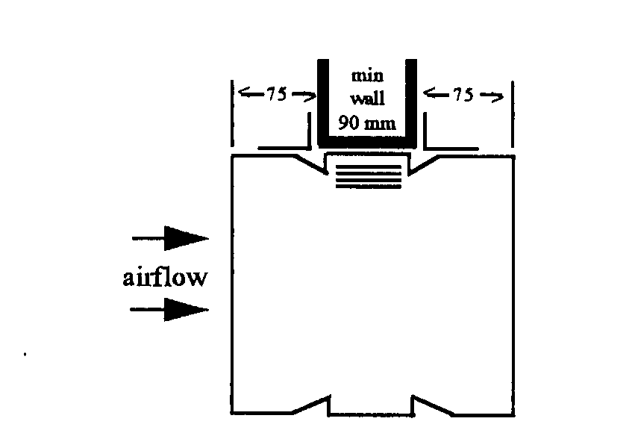

Standard Wall Mounting

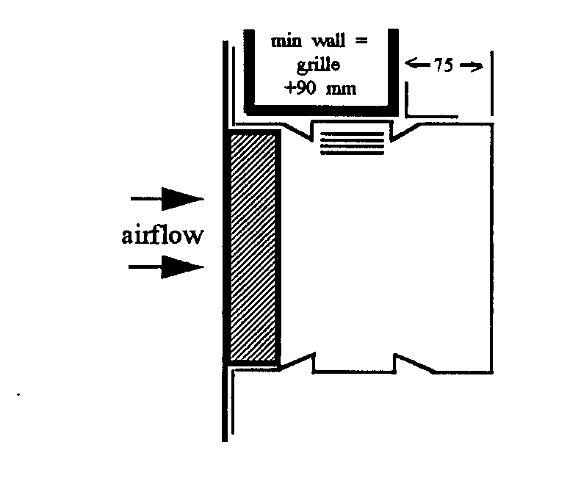
Wall Mounting with Grille

OTHER DAMPER PRODUCTS
- Fire Dampers:
Multi-Blade Fire Damper, Single Blade Fire Damper, Circular Fire Damper, 'Volume-Fire Damper, Ceiling Fire Damper
- Volume Control Dampers:
Low Leakage Volume Damper (standard), Ultra Low Leakage Volume Damper, High Performance Volume Damper, Min/Max Damper, Face & Bypass Damper, Zone Damper, Non-Return & Barometric Damper
- Sub Ducts
- Damper Accessories:

