Riley Air Control Systems Pty Ltd.


SPECIFICATION DATA

 | 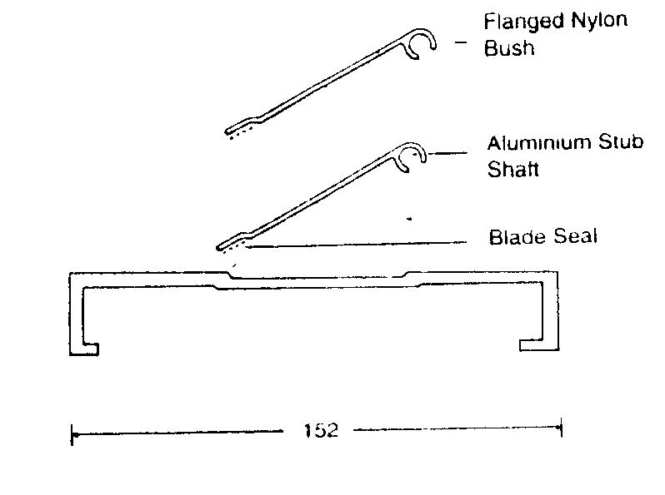 | NON RETURN DAMPERS  - All blades individually hinged on stainless steel  stub shafts  - standard with long life nylon bushes  - Blade tips sealed for quiet operation.  BAROMETRIC DAMPERS  - All blades ganged together for uniform  movement  - Dampers are counter balanced to allow  adjustment for infinite opening pressures
SUGGESTED SPECIFICATIONS

Non-Return Dampers:
Dampers shall be manufactured from 3mm thick extruded Aluminium 6063-T5 alloy.
Blades shall be of a single unit design, 75mm / 130mm wide with offset tip for the blade seal.
Blades shall be manufactured from 1.5mm extruded Aluminium 6063-T5 alloy.
Individual blades shall be hinged on a 6mm diameter stainless steel stub shaft which shall rotate in
a flanged nylon bush.

Barometric Dampers:
Dampers shall be Non-Return Dampers above with the following inclusions:
Counter balanced - adjustable for infinite opening pressures.
Blades - Ganged together for uniform movement.
Specify if airflow is horizontal, vertical or vertical down.
Specify location of counterbalance i.e.
(a) Internally on blade or
(b) Externally on extended shaft.

The dampers are designed to work in a Laminar air flow environment between 2m/s and 8m/s
and a maximum static pressure of 500pa.
The operating temperature range is 80ºC.
NOTE: DO NOT FIT DAMPER NEAR FAN DISCHARGE OR IN OTHER TURBULENT AREAS.

Head Office: Riley Air Control Systems
3 / 78-80 Bellingara Road
Miranda NSW 2228
Ph: (02) 9544 8854
Fax: (02) 9544 8545

Riley Air Control Systems Pty Ltd.

SPECIFICATION DATA

Installation and maintenance of non return and barometric dampers.

Installation

Do not fit damper near fan discharge or in turbulent air.

Before installation ensure that the damper is not damaged and blades operate freely. Blades are some
times taped closed for transport or in the case of barometric the blades are locked with the link nuts.

Install damper square and flat. Carry out final field adjustment to barometric and linked blade type,
ensure that linkages are free. This is achieved by adjusting tension on the nyloc link nuts. These can
require adjustment after transport and or installation.

Barometric dampers have a weight fitted which may require adjustment to suit your air flow.

If damper is fitted in duct run an access panel should be fitted for future maintenance.

Maintenance

Bearings require regular lubrication we recommend the use of silicone spray every 6 months ( In high corrosive environment this may be required every 4 months. ) Linkages on barometric dampers should
be checked and lubricated every 6 months ( In high corrosive environments this may be required every 4 months. ) Light machine oil or silicone spray can be used. Dampers should be kept clean of any outside pollutant’s and corrosive build-ups by use of pressure cleaners or solvent and brush method this would
be required every 4 months.

Riley Air Control Systems Pty Ltd.
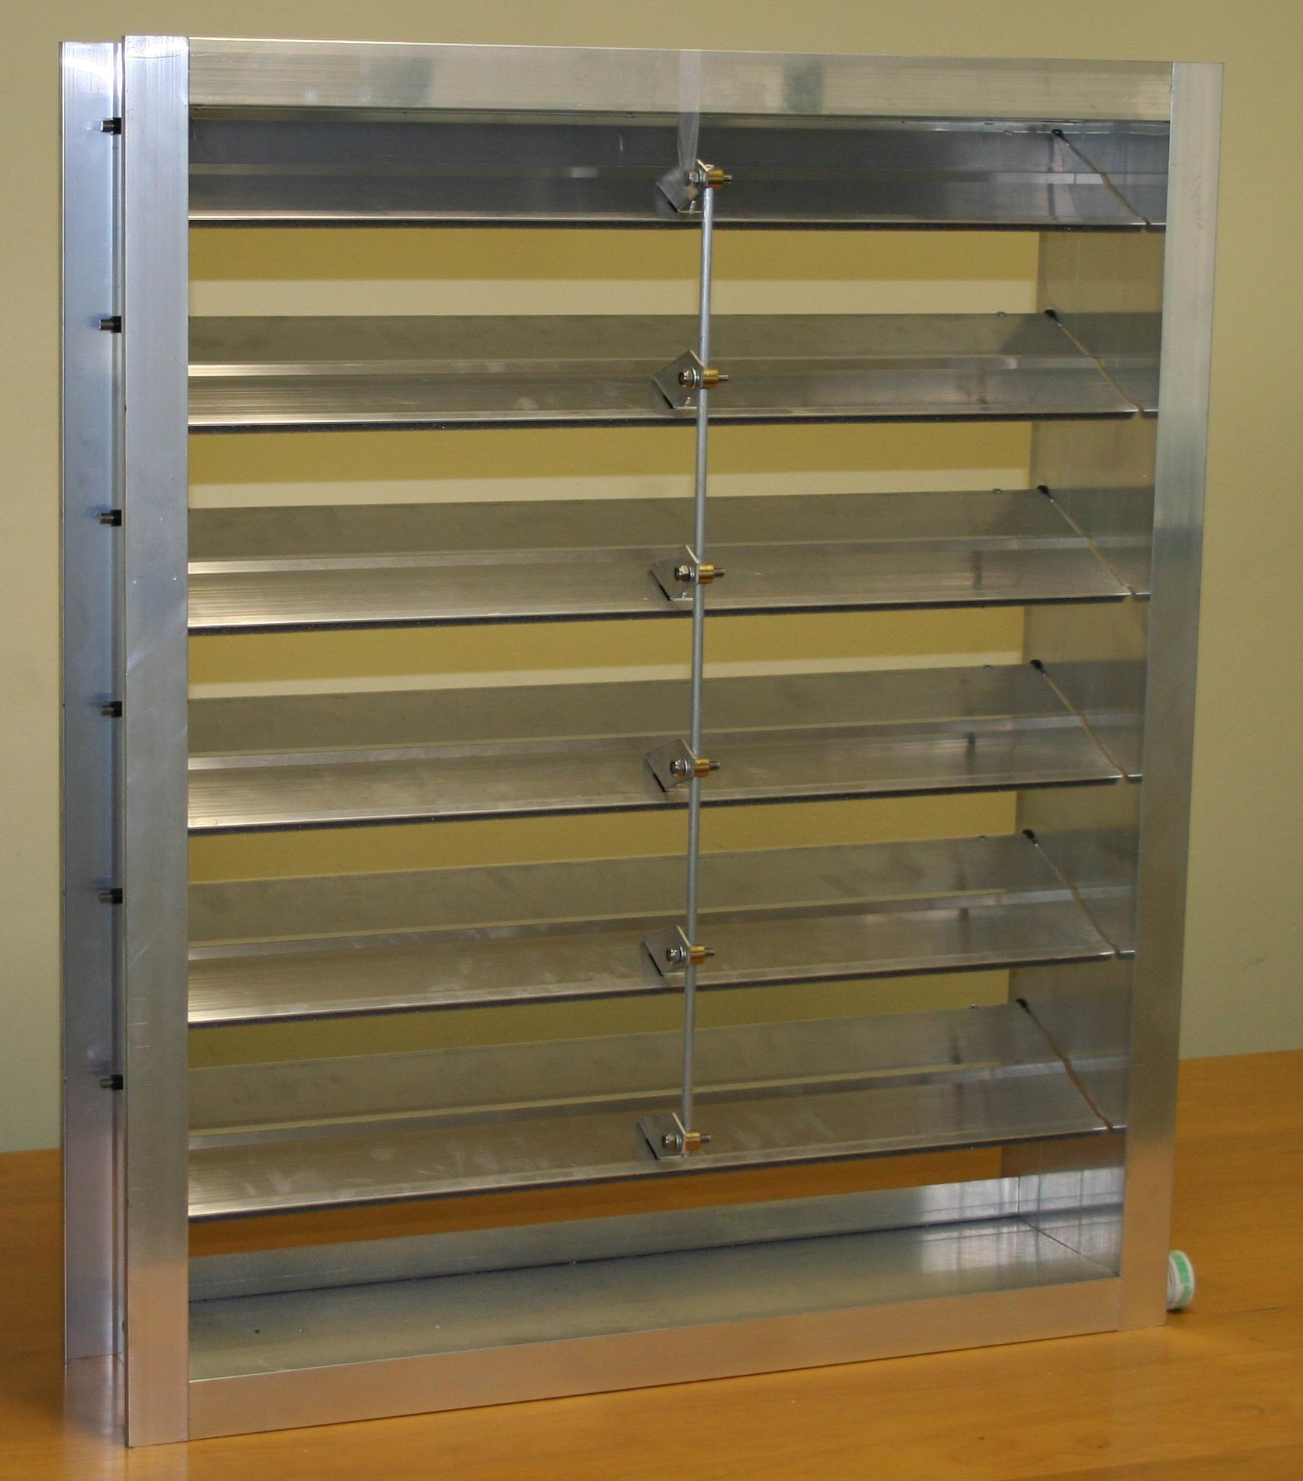

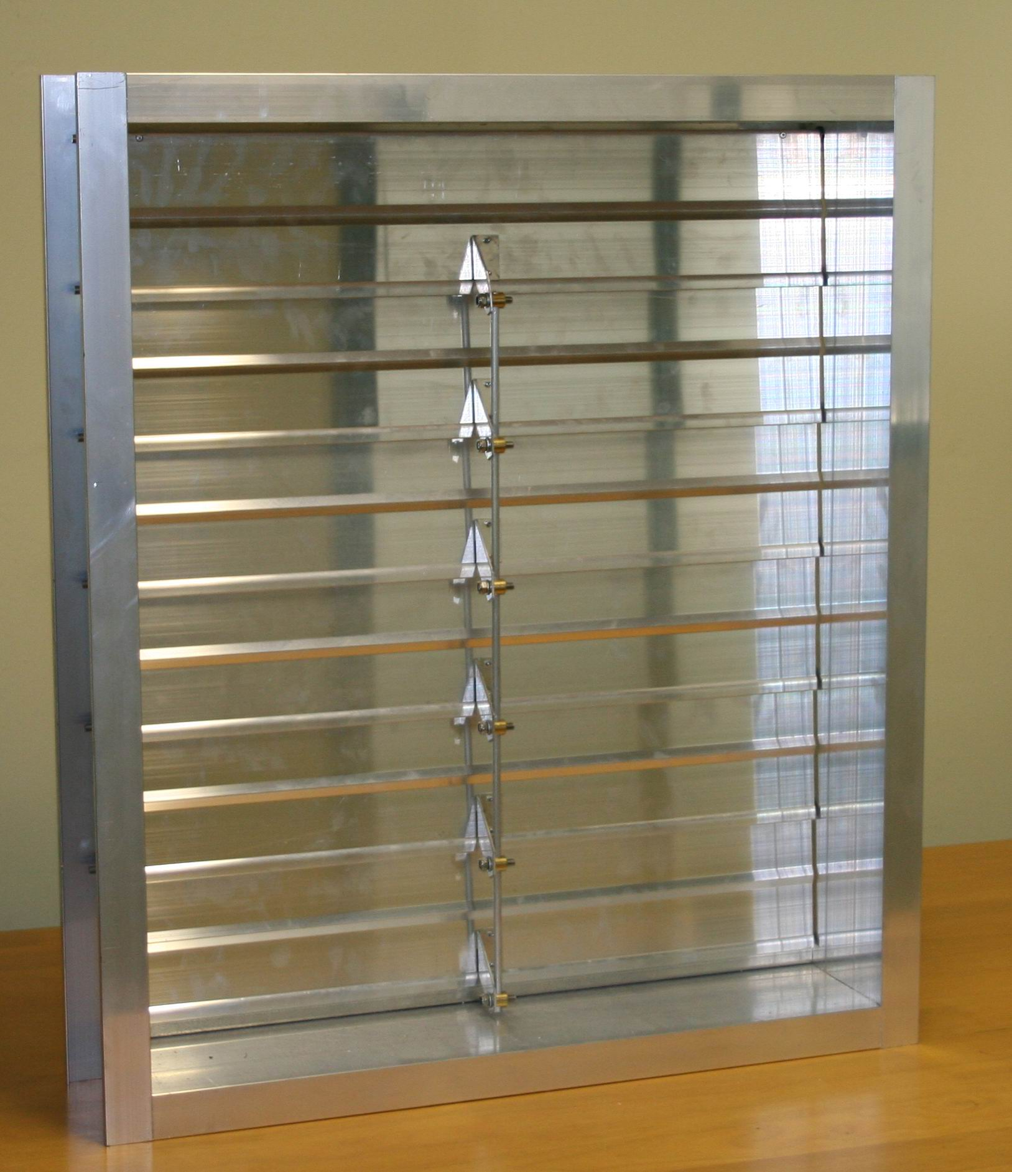
Riley Air Control Systems Pty Ltd.

SPECIFICATION DATA

1. Application: Standard stainless steel or Galvanised steel Non Return Damper is an air handling device used to
control air flow volume in ventilating, heating and air conditioning systems.
Parallel action blades – All blades rotate in the same direction.
2. Features:
2.1 Stainless steel and Galvanised steel Non Return Dampers meet the requirements for economical air flow
control.
2.2 Sizes:
Individual Non Return Dampers can be specified for manufacture in the following ways
- Design selection to the nearest module sizes from 150mm width in increments of 50mm by 150mm height also in increments of 50mm.
- Each module maximum size 1000 x 2400. When application requires a larger dimension in either direction, a multi module is constructed of two or more section. (Factory or site assembly.)
3. Blades: Constructed of 0.8mm to 1.2mm Stainless steel or Galvanised steel folded for rigidity.
  - Bearings and Axles:
- Bearings are delrin or oil retaining sintered porous bronze “iolite” fan 6.
- Axles and drive shafts are 12.7mm stainless steel.
4. Maintenance:
Bearings require regular lubrication. We recommend the use of silicone spray on Delrin bearings and light machine
oil on sintered bronze bearings. Linkages on blades should be checked and lubricated with light machine oil every 6
months or in a high corrosive environment this may be required every 4 months.

Head Office: Riley Air Control Systems
3 / 78-80 Bellingara Road
Miranda NSW 2228
Ph: (02) 9544 8854
Fax: (02) 9544 8545

