 | RILEY AIR CONTROL SYSTEMS P L
Access Doors

SPECIFICATION DATA

The Access Door is a robust, insulated door  pre hung in a heavy frame so that the unit is  complete ready for immediate installation.  Each door incorporates two sets of adjustable  hinges and handles (as per table) and all  external hardware is chrome plated. Standard  sizes are as shown and special sizes can be  made to order. |  | 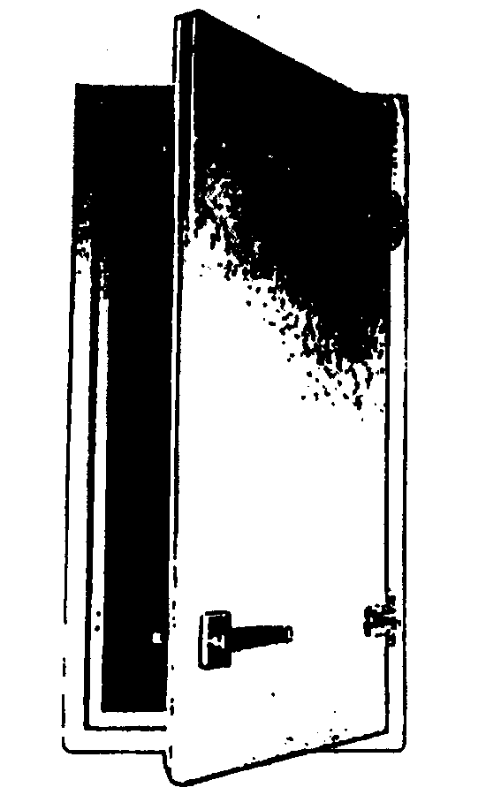
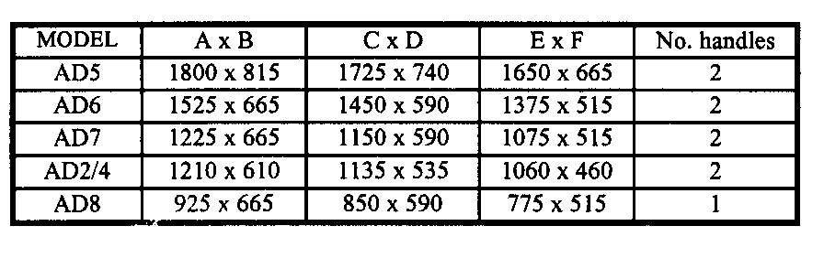
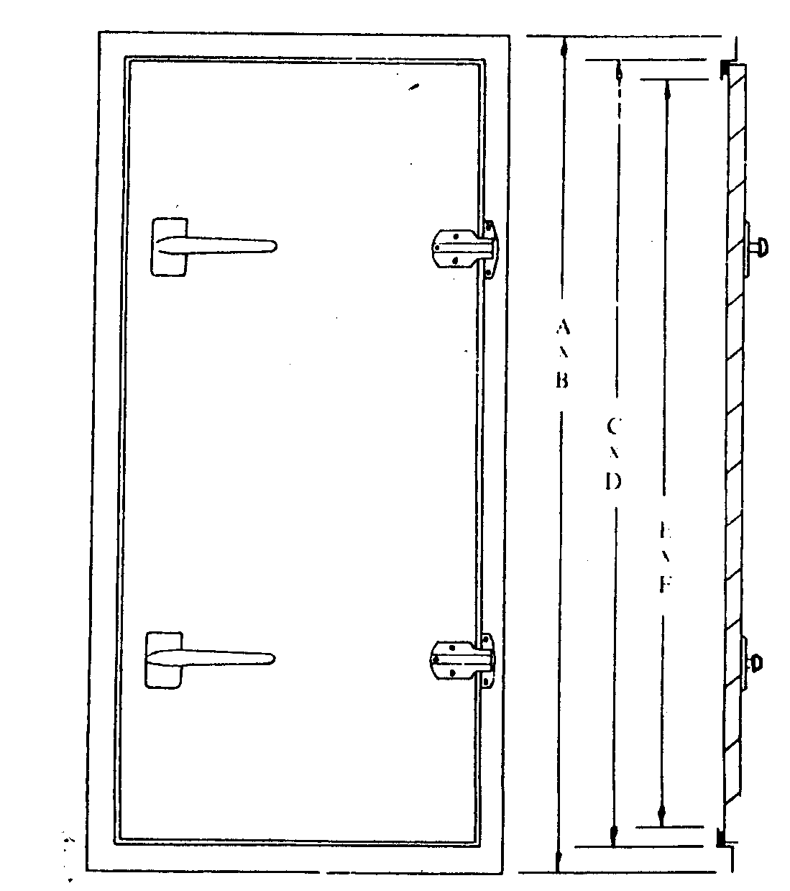 |  | SPECIAL FEATURES INCLUDE  - Adjustable hinges  - Chrome fittings  - Heavy duty rubber gasket  - Inside “escape” handles  - Painted finish is optional  MECHANICAL FEATURES  Construction - Frame is made from 2.0mm galvanised steel - mitred, welded and ground.  Door bedding is of 1.2mm galvanized steel to form inside and outside skin.  Insulation - 25mm thick, in bat form.  Door Seal - The heavy duty gasket compresses on door closure and provides the air seal.
Riley Air Control Systems
3/78-80 Bellingara Road
Miranda NSW 2228
A.B.N 80 003 437 732

