 | RILEY AIR CONTROL SYSTEMS P L

Access Panels

SPECIFICATION DATA

Ergonomic Sizing

The standard duct access panel sizes have been selected after careful study of the needs of site engineering and maintenance personnel. Each door allows a different degree of access, enabling the most appropriate unit to be specified, depending on the type of equipment installed in the ducting, and the likely maintenance needs.

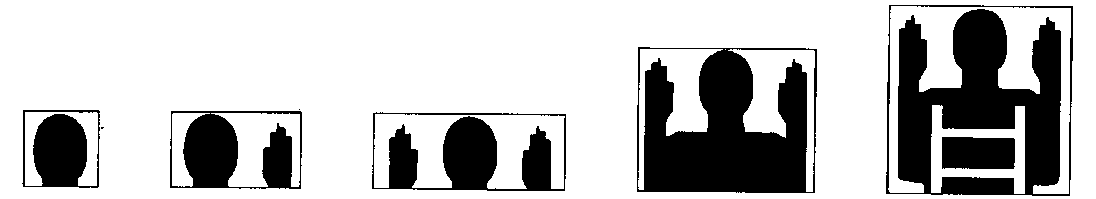
0800 0810 0820 0830 0840
hand / sight one hand and sight two hands and sight head and shoulders body entry plus ladder

NOTE: These additional cam locks on model 0820 only.

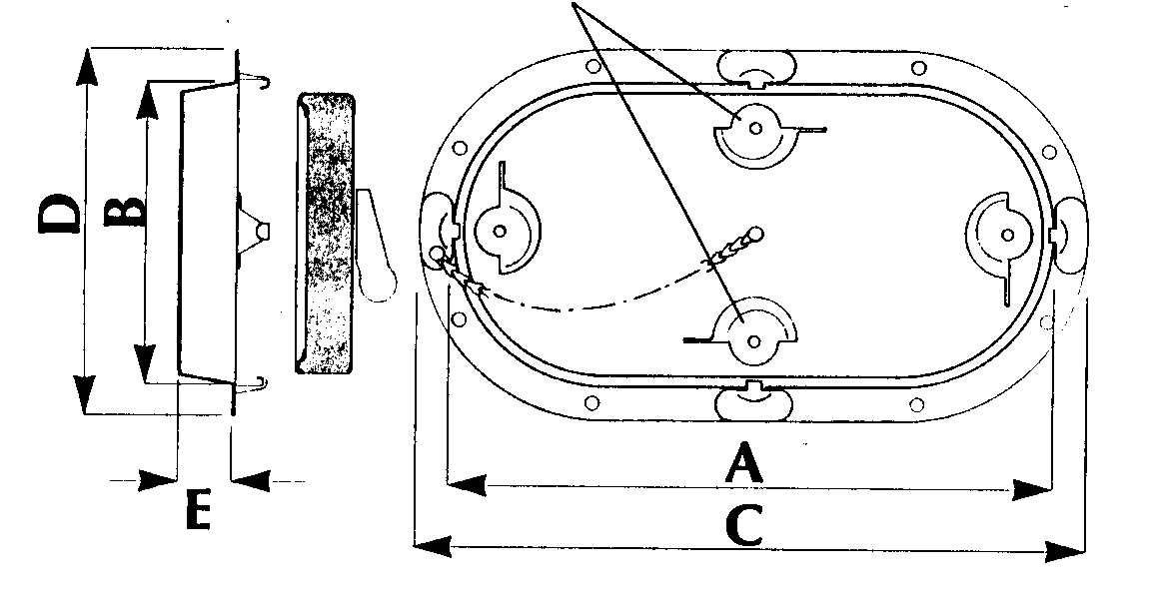 | MODEL  Nom Size  A  B  C  D  E |  | 0800  200x125  203  127  241  165  30 |  | 0810  300x150  298  157  349  197  30 |  | 0820  460x250  462  258  502  298  30
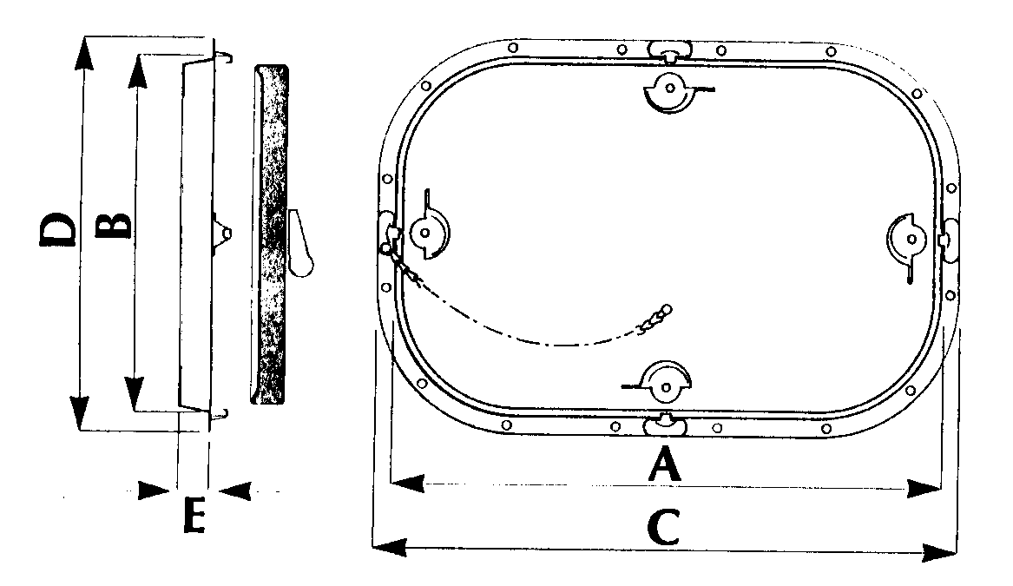 |  | MODEL  Nom Size  A  B  C  D  E |  | 0830  520x360  538  355  578  400  30 |  | 0840  635x430  640  433  679  476  30

Head office: Riley Air Control Systems
3/78-80 Bellingara Road
Miranda NSW 2228
Ph: 02 9544 8854
Fax: 02 9544 8545
A.B.N. 80 003 437 732

