Riley Air Control Systems Pty Ltd.
VDL/VDU Series

Low/Ultra-Low Leakage

Volume Control Dampers

SPECIFICATION DATA

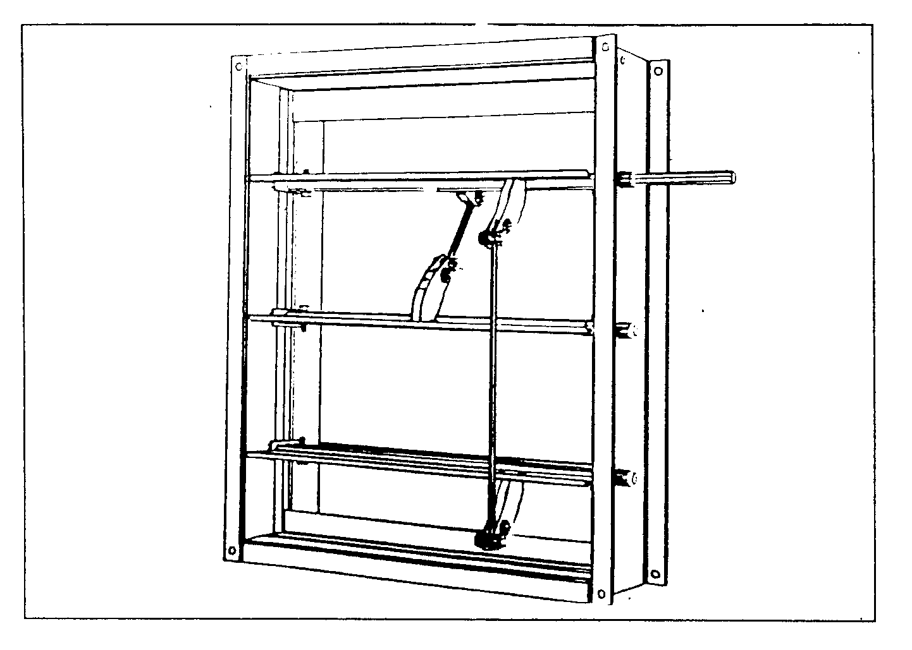

General

The VDL and VDU Series Volume Control Dampers provide highly efficient airflow control in conventional air handling systems. VDL is a standard low leakage damper and the VDU is the ultra-low leakage version damper. Both damper types are available with parallel blade configuration for variable air volume application and opposed blades for air mixing application.

Interlocking blade edges and spring steel side seals provide the basis for reduced (LOW) leakage - the ULTRA LOW leakage version is fitted with silicone rubber tip seals. Specially formed standard components and non-corrosive bearings conform to specifications required for high quality, low leakage, maximum rigidity and low operating torque. This allows the use of smaller or fewer actuators.

Multiple sections are inter-connected with a solid drive shaft and provide, together with individually adjustable internal blade linkages, a positive connection for optimum close-off sealing.

Total damper design and close manufacturing tolerances of Blendair dampers result in LONG DAMPER LIFE, SMOOTH & RELIABLE CONTROL and ENERGY SAVING.
Features

- Spring stainless steel side seal minimises blade end leakage

- 9-breaks interlocking blades ensure rigidity and tighter close-off seal

- Ground stainless steel blade axles and ‘Delrin’ or Oilite (optional) bearings reduce friction and torque requirements, thus enabling smaller actuators

- Rigid galvanised steel construction resists corrosion and extends damper life

- Corrosive-resistant internal blade linkage allows easy maintenance and field adjustment

- Clip-on design of seal allows field retro-fit

- Ultra-low leakage results in energy saving

VDL, VDU: VOLUME CONTROL DAMPERS

DESCRIPTION & FUNCTION
The VDL & VDU Series Low Leakage and Ultra Low Leakage dampers are the standard range of Blendair Volume Control Dampers which provide efficient airflow control in conventional air handling systems. Both damper types are available in parallel and opposed blade configuration.

Spring steel side seals and interlocking blade edges are the principle design features for low leakage with additional silicone seals achieving extra low leakage rates. Low friction internal blade linkages and blade bearings ensure extra low torque and smooth and efficient modulating operation, it allows the use of smaller or fewer actuators.

Dampers are installed - as standard - with horizontal blade orientation. The opening, closing or modulation of the interconnected blades is effected by electric or pneumatic actuators initiated by control signals. Dampers are also available for manual control setting.

MODELS
- VDL: Low Leakage Volume Control Damper for standard application to control airflow in conventional air handling systems
- VDU: Ultra Low Leakage Volume Control Damper, with rubber seals for airflow control applications requiring extra tight shut-off

GUIDE SPECIFICATION (for the Engineer)
Volume Control Dampers installed shall be of design and construction as the VDL/U Series supplied by Blendair, meeting requirements of low leakage, extra low operating torque and smooth operation.

Dampers shall be of solid corrosive resistant steel construction (Aluminium optional) to prevent distortion or twisting during transit, installation and operation. Blades shall be of 9-break design and of maximum 1200 mm length and shall be individually adjustable to obtain

optimum air shut-off. Drive blades over 800 mm length shall be fitted with full-length stainless steel shaft to provide even torque distribution over blade length. Blades shall be pivoting on 12.7 mm S/S shafts and ‘Delrin’ or ‘Oilite’ sintered bronze bearings.

DAMPER TYPES & APPLICATIONS
Dampers are supplied with two types of blade configuration:
Parallel Blade Dampers are constructed so that each blade rotates in parallel with or in the same direction as the blade next to it. The rotation changes the direction of the airflow and can provide mixing and linear airflow characteristics, with only a small increase in airflow resistance.
Major control applications:
Return Air
Outdoor or Exhaust Air (w/o weather louvre or bird screen)
Bypass (w/o perforated baffle)
Two Position or On/Off (all applications)
Opposed Blade Dampers are constructed so that adjacent blades rotate opposite to each other. The rotation does not change the direction of the airflow, but it does increase the airflow resistance as the air is funnelled through a smaller opening. Opposed blade dampers must be opened further to obtain the same airflow as a parallel damper.
Major control applications:
Outdoor or Exhaust Air (with weather louvre or bird screen)
Coil Face
Bypass (with perforated baffle)

DAMPER ORDERING SPECIFICATION
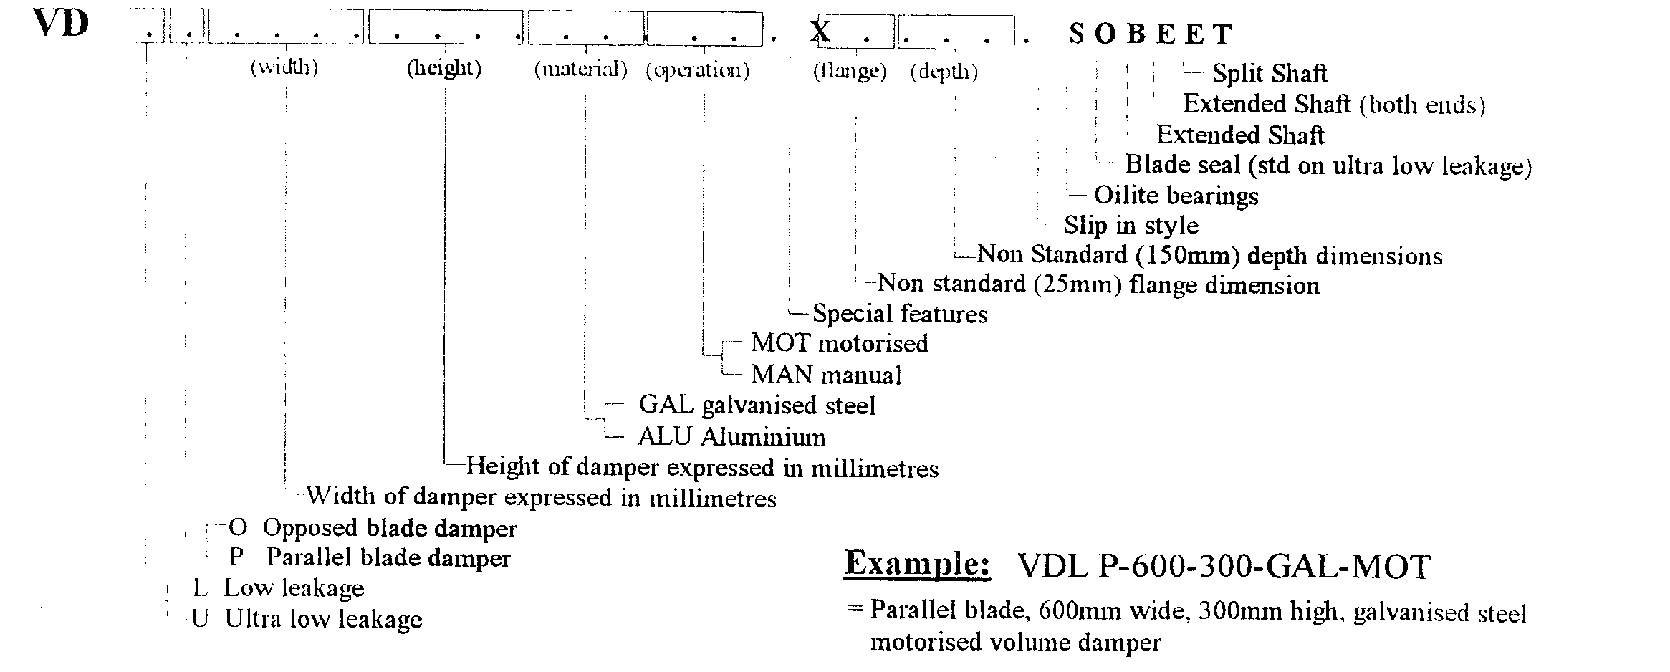

VDL, VDU: VOLUME CONTROL DAMPERS

DAMPER SIZING SPECIFICATION
Modules are supplied in the following standard sizes:
Single Module: from 150mm x 150mm (min)
to 1200mm x 2400mm (max)
Size Increment: 50mm
Multi Modules, and
Non-Standard Sizes: available, for details refer to Sales or Factory
Note: When specifying damper sizes (width and height), quote internal duct dimensions.

SHIPPING WEIGHTS (Kg) (GAL construction)
Height  (mm) | 200 | 400 | Width  600 |  | (mm)  800 | 1000 | 1200
200 | 9 | 12 |  | 16 | 19 | 22 | 27
400 | 14 | 18 |  | 22 | 27 | 31 | 36
600 | 19 | 24 |  | 29 | 34 | 39 | 46
800 | 24 | 30 |  | 36 | 42 | 48 | 55
1000 | 30 | 36 |  | 43 | 50 | 56 | 65
1200 | 35 | 42 |  | 50 | 57 | 65 | 74
1400 | 40 | 48 |  | 57 | 65 | 73 | 84
1600 | 45 | 54 |  | 63 | 73 | 82 | 93
1800 | 50 | 60 |  | 70 | 80 | 90 | 103
2000 | 55 | 66 |  | 77 | 88 | 99 | 112
2200 | 61 | 72 |  | 84 | 95 | 107 | 122
2400 | 66 | 78 |  | 91 | 103 | 115 | 131
Note: For weights of multi modules, add total weight by interpolating with above weight table.

SPECIFICATIONS - Construction
Materials & Finishes:
- Damper frame and blades: zinc-coated ("galvanised") steel sheet, complying with AS 1397 with a Coating Class not less than Z275. Damage to the zinc-coating, eg. through welding, is remedied by appropriate cleaning method and covered with special 'galvanising' paint.
- Dampers are also available in Marine Grade Aluminium (optional) or Stainless Steel (see Model Series VDH), using same construction as standard VDL damper.

Frame:
Standard Construction: Press-formed Gal Steel
Material Thickness: 2.0 mm
_| 150mm | _| 140mm |_
25mm 25mm
_ _
Welded U-Channel ‘Slip-in’
(standard) (optional)

Blades:
Standard Construction: Roll or press-formed Gal Steel
Material Thickness: 1.6 mm

Blade Seals:
Blade Ends: Spring stainless steel continuous strips (Side Seal)
Blade Edge: Clip-on, rubber. Available in low temperature and in high temperature 200ºC suitable for smoke spill.
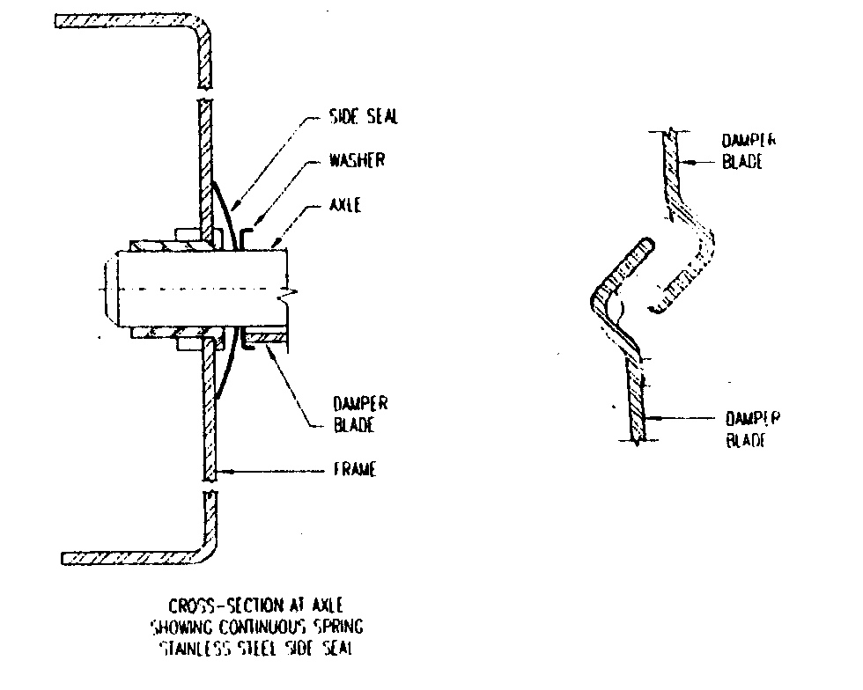
Blade Bearings:
Bearing Types: ‘Delrin’ (standard) for operating temperature-40 to +100 degree C and horizontal blade mounting.
‘Oilite’ sintered bronze bearings (optional) for vertical blade mounting or for high temperature application to max 200 degree C (see also SSD Dampers)

Blade Axle & Drive Shaft:
Material: 12.7 mm diameter ground 304 Stainless Steel
Blade Axles: Blades are fastened to 50 mm long axles with special self-locking, shake-proof bolts.
Drive Shaft: Drive Blade is fitted with 225 mm long drive shaft which extends outside the frame for external motor mounting, but is retracted for protection purpose during transit. Dampers with over 800 mm blade length or over 0.6 m2 are fitted with full-length drive shaft.

Manual Drive Hardware:
For manual operation, dampers are fitted with adjustable and lockable Quadrant and supplied without side seals.

Blade Linkage Hardware:
Linkage Bracket: Press-formed, zinc-plated mild steel
Note: Extra heavy plating available for high corrosive atmosphere applications (optional). S/S also available
Linkage Connection Rod:
6.35 mm electro-galvanised mild steel
Trunnions: Brass
Set Screws & Blade Mounting Bolts:
Zinc plated mild steel

VDL, VDU: VOLUME CONTROL DAMPERS

Blade Orientation:
Dampers are available in two blade orientations (to be specified by customer): Parallel and Opposed.

SPECIFICATIONS - Technical
Maximum Pressure Differential:
1.5 kPa (6 Inch WC)
Maximum Approach Velocity:
20 m/sec (4000 fpm)
Temperature Range:
-40 to +100 degree C (standard)
-40 to +93 degree C (with seal)
Leakage Characteristics:

SPARE PARTS
Model No. | Description
VD-01 | DELRIN bearings
VD-02 | OILITE bearings
VD-03 | Trunnion (brass)
VD-04 | Trunnion set screw
VD-05 | Blade axle
VD-06 | Axle lock screw
VD-07 | Nut & bolt (for drive shaft)
VD-08 | Large linkage
VD-09 | 2 hole linkage
VD-10 | Small linkage
Note: Other parts may be available on special request

INSTALLATION
Important! Improperly installed dampers prevent blades from sealing (see sketch below). Gaps between the blades and frame indicate that the damper is installed ‘out of square’ or ‘out of flat’. These misalignments will cause increased leakage and can result in blade-to-linkage bind or non-closure of blades, thus overloading the damper actuator or render it inoperative.

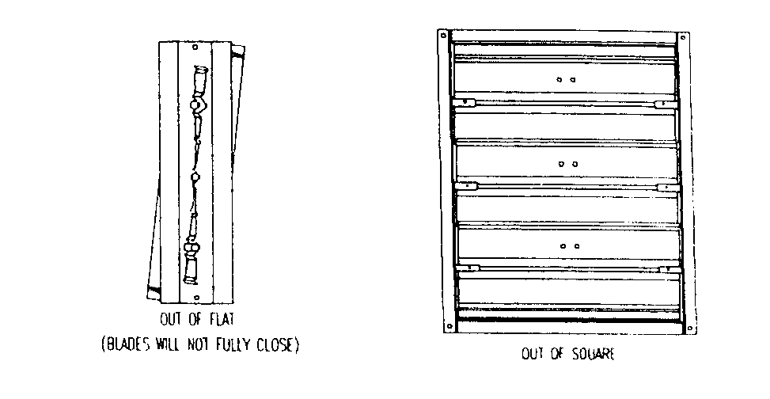

Installation Hints:
1. Always observe and follow instructions on label affixed to damper.
2. Before installation, ensure that damper is not damaged and blades operate freely.
3. Allow sufficient room on side of damper for mounting of actuator.
4. Install damper ‘square and flat’ as per warning above. Carry out final field adjustment to blade linkages, ensuring that all damper close tightly and tighten all sets-crews
5. Perform trial run of damper & actuator assembly, before attaching other end of duct work to damper.

OTHER DAMPER PRODUCTS
- Volume Control Dampers:
High Performance Volume Damper, Smoke Spill Damper, Min/Max Damper, Face & Bypass Damper, Zone Damper, Non-Return & Barometric Damper
- Fire Dampers:
Multi-Blade Fire Damper, Single Blade Fire Damper, Circular Fire Damper, Volume-Fire Damper, Ceiling Fire Damper, Curtain Fire Damper
- Sub Ducts
- Actuators & Damper Accessories:

Head Office: Riley Air Control Systems Pty. Ltd.
3/78-80 Bellingara Road
Miranda NSW 2228
Phone: (02) 9544 8854 Fax (02) 9544 8545

