Riley Air Control Systems Pty Ltd.
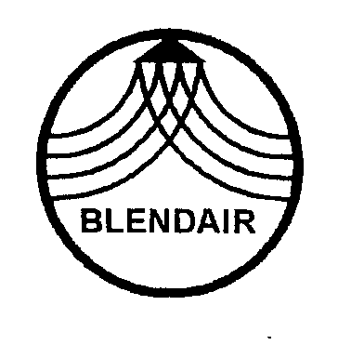 | SSD Series  Ultra-Low Leakage  Smoke Control Dampers

SPECIFICATION DATA

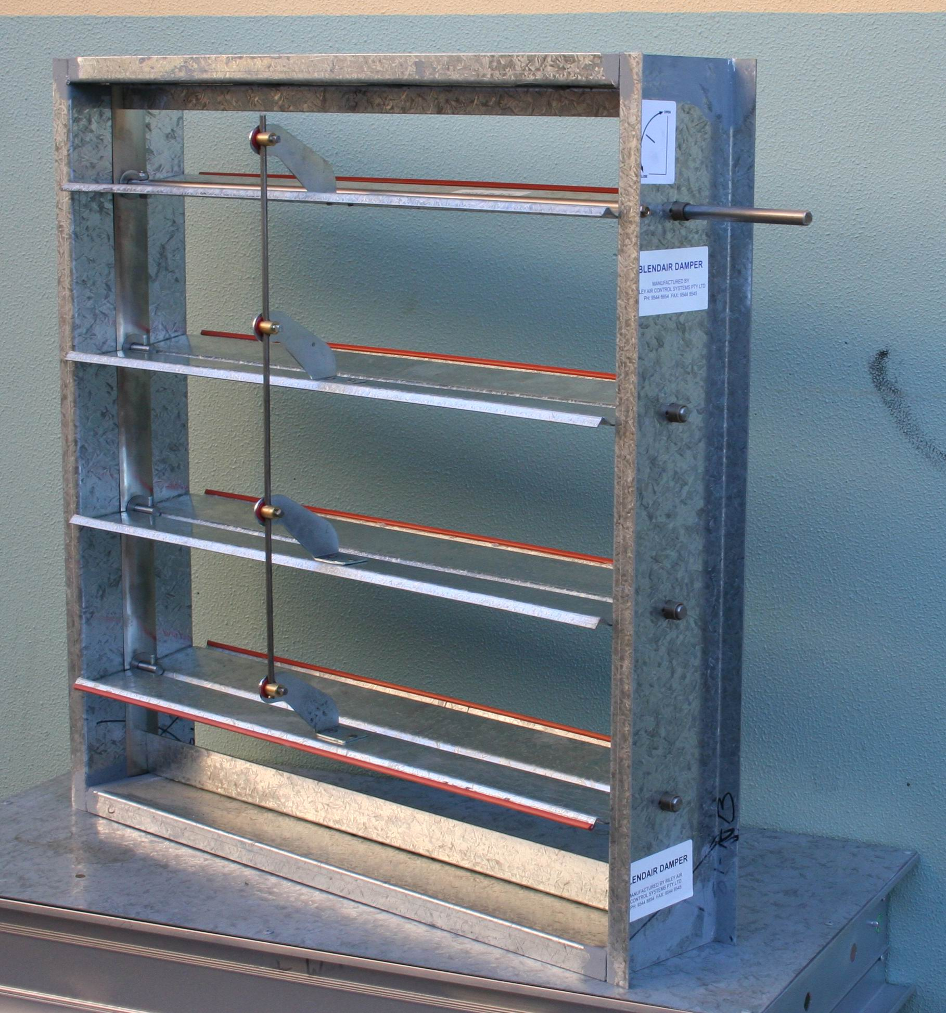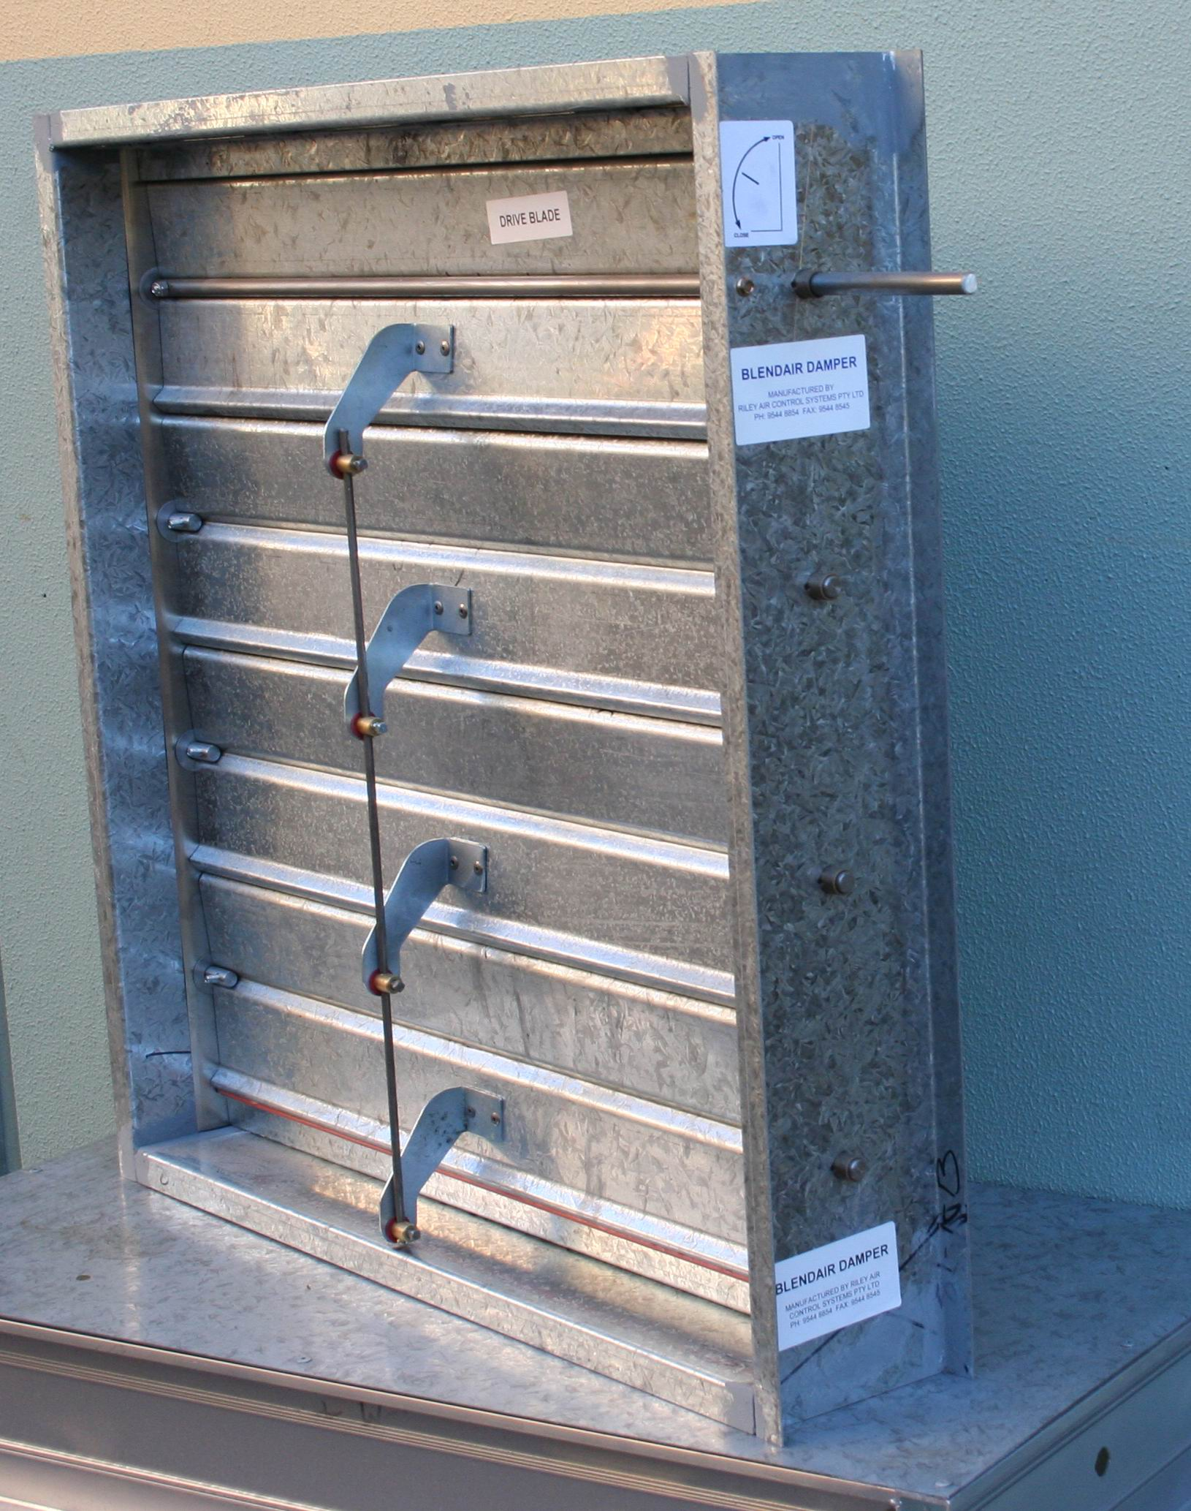
 | General |  |  |  |  |  |  |  |  |  | Features
 | The SSD Smoke Spill Control Damper is a safety device to control the spread of hot smoke in an emergency situation and to efficiently control the airflow in conventional air handling systems. The SSD is an ultra-low leakage damper, which operates safely up to 200 degree C and meets AS1668 requirements. It will be supplied with parallel blades as standard (opposed blades - optional).  Interlocking blade edges and spring steel side seals provide the basis for reduced leakage. For ultra-low leakage the blades are fitted with high temperature silicon-rubber seals that further reduce the leakage. Specially formed standard components and non-corrosive bearings conform to specifications required for high quality, low leakage, maximum rigidity and low operating torque. This allows the use of smaller or fewer actuators.  Multiple sections are inter-connected with a solid drive shaft and provide - together with individually adjustable internal blade linkages - a positive connection for optimum close-off sealing.  Total damper design and close manufacturing tolerances of Blendair dampers result in LONG DAMPER LIFE, SMOOTH & RELIABLE CONTROL AND ENERGY SAVING. |  |  |  |  |  |  |  |  |  | - Spring stainless steel minimises blade end leakage  - Interlocking blades ensure rigidity and tighter close-off seal  - Ground stainless steel blade axles and Oilite bearings reduce friction and torque requirements, thus smaller actuators  - Rigid galvanised steel construction resists corrosion and extends damper life  - Corrosive-resistant internal blade linkage allows easy maintenance and field adjustment and interchangeable components  - High temperature silicone rubber for smoke control operation at 200 degree C on ultra-low leakage dampers  - Low leakage results in energy saving  - Tested to AS 1530.7 on 19th June 2007
SSD High Temperature Smoke Control Dampers
DESCRIPTION & FUNCTION  The SSD Series SMOKE Control Damper is a safety device to control the spread of hot smoke in emergency situations; it also efficiently controls the airflow in conventional air handling systems. This ultra-low leakage damper meets AS 1668 requirements for operation at temperatures 200 degree C for two (2) hours.  Spring steel side seals and interlocking blade edges fitted with high temperature silicon-rubber seals are the principal design for ultra low leakage. Low friction internal blade linkages and blade bearings provide the basis for low torque and smooth and efficient modulating operation - it allows the use of smaller or fewer actuators.  Dampers are installed - as standard - with horizontal blade orientation. The opening, closing or modulation of the interconnected blades is effected by electric or pneumatic actuators initiated by control signals.  MODEL  SSD: Ultra low leakage SMOKE Damper, for  high temperature applications requiring tight  shut off. The Ultra Low Leakage damper is  supplied as standard with silicon rubber  blade seal and parallel blade configuration.  GUIDE SPECIFICATION (for the Engineer)  SMOKE Dampers installed shall be of design construction as the SSD series supplied by Blendair, meeting requirements of extra low leakage, low operating torque and smooth operation.  Dampers shall be of solid corrosive resistant steel construction (or S/S optional) to minimise distortion or twisting during transit, installation and operation. Blades shall be maximum 1200mm length and shall be individually adjustable to obtain optimum air shut-off. Drive blades over 800mm length shall be fitted with full-length stainless steel shaft to provide even torque distribution over blade length. Blades shall be pivoting on 12.7mm S/S shafts and ‘Oilite’ sintered bronze bearings. |  |  |  |  |  |  |  |  |  | DAMPER TYPES & APPLICATIONS  Dampers are supplied with two types of blade configuration:  Parallel Blade Dampers are constructed so that each blade rotates in parallel with or in the same direction as the blade next to it.  Opposed Blade Dampers are constructed so that adjacent blades rotate opposite to each other.  DAMPER SIZING SPECIFICATION  Modules are supplied in the following standard sizes:  Single Module: from 150mm x 150mm (min)  to 1200mm x 2400mm (max)  Size Increment: 50mm  Multi Modules and standard sizes available on request.  Note: When specifying damper sizes (width and  height), quote internal duct dimensions.
SSD High Temperature Smoke Control Dampers

SHIPPING WEIGHTS (Kg)  (Galvanised construction) |  |  |  |  |  |  |  |  |  |  | Blade Seals:  Blade Ends: Spring stainless steel continuous strips  (Side Seal)
Height  (mm) |  | 200 | Width  600 | (mm)  800 | 1000 | 1200 |  |  |  |  |  | Blade Edge: Clip-on, silicon rubber (optional  200ºC)
200 |  | 9 | 16 | 19 | 22 | 27 |  |  |  |  |  | 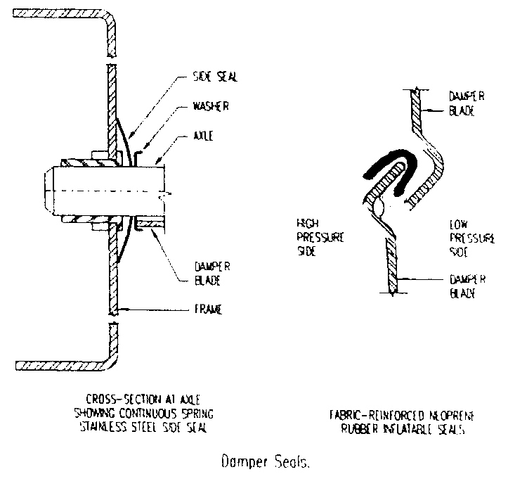
400 |  | 14 | 22 | 27 | 31 | 36
600 |  | 19 | 29 | 34 | 39 | 46
800 |  | 24 | 36 | 42 | 48 | 55
1000 |  | 30 | 43 | 50 | 56 | 65
1200 |  | 35 | 50 | 57 | 65 | 74
1400 |  | 40 | 57 | 65 | 73 | 84
1600 |  | 45 | 63 | 73 | 82 | 93
1800 |  | 50 | 70 | 80 | 90 | 103
2000 |  | 55 | 77 | 88 | 99 | 112
2200 |  | 61 | 84 | 95 | 107 | 122
2400 |  | 66 | 91 | 103 | 115 | 131
Note: For weights of multi modules, add total weight by interpolating with above weight table.  SPECIFICATIONS - Construction  Materials & Finishes  - Damper frame and blades: zinc-coated (‘galvanised’) steel sheet, complying with AS 1397 with a Coating Class not less than Z275. Damage to the zinc-coated. eg. through welding, is remedied by appropriate cleaning method and application of special ‘galvanising’ paint.  Frame:  Standard Construction: Press-formed Gal Steel Material Thickness: 2.0mm  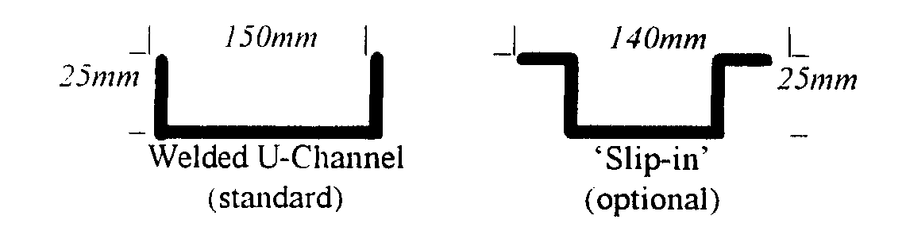  Blades:  Standard Construction: Roll or press-formed Gal Steel  Material Thickness: 1.6mm   |  |  |  |  |  |  |  |  |  |  | Blade Bearings:  Bearing Types: ‘Oilite’ sintered bronze bearings for high temperature application (max 200ºC)  Blade Axle & Drive Shaft:  Material: 12.7mm diameter ground 303 Stainless  Steel  Blade Axles: Blades are fastened to 50mm long  axles with special self-locking, shake  proof bolts.  Drive shaft: Drive Blade is fitted with 225 mm  long drive shaft that extends outside the  frame for external motor mounting, but  is retracted for protection purpose during  transit.  Dampers with over 800 mm blade length  or over 0.6m² are fitted with full-length  drive shaft.  Blade Linkage Hardware:  Linkage Bracket: Press-formed, zinc plated mild  steel  Note: Optional extra heavy duty  plating or stainless steel linkages  are available for high corrosive  atmosphere applications.  Linkage Connection Rod:  6.35mm 303 stainless steel.  Trunnions: Brass  Set Screws & Blade Mounting Bolts:  Zinc plated mild steel  Blade Orientation:  Dampers are available in two blade orientations (to be specified by customer):  Parallel (standard for SSD) and Opposed (optional)

SSD High Temperature Smoke Control Dampers
SPECIFICATIONS - Technical  Maximum Pressure Differential: 1.5kPa (6 Inch WC)  Maximum Approach Velocity: 20 m/sec (4000 fpm)  Temperature Range: -40 to +200 degree C  Leakage Characteristics:  ULTRA LOW LEAKAGE CURVE  SILICONE SEALS  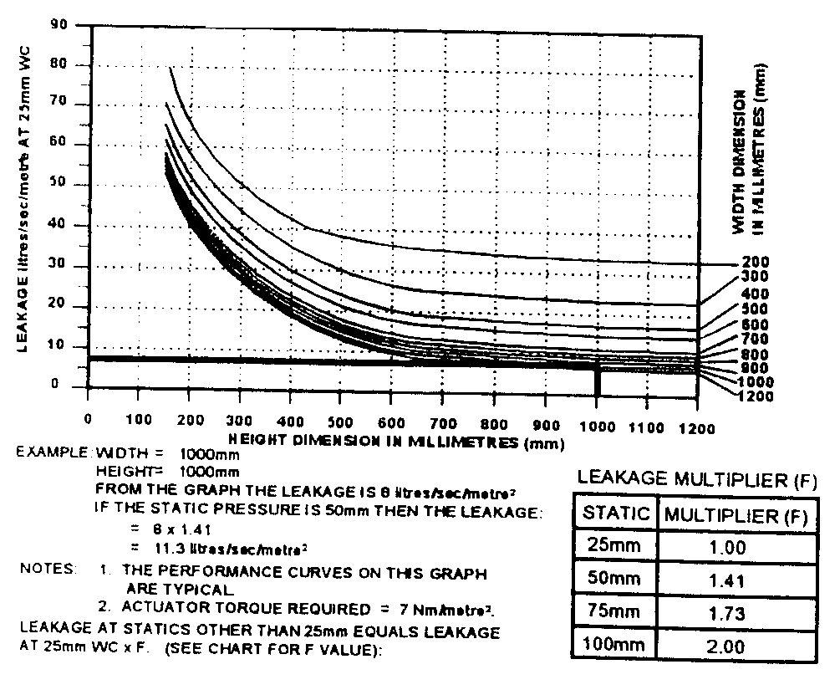  Riley Air Control Systems Pty Ltd  3 / 78-80 Bellingara Road  Miranda NSW 2228  Ph: (02) 9544 8854  Fax: (02) 9544 8545  Email: info@rileyair.com.au  ABN 80 003 437 732 |  |  | INSTALLATION  Important! Improperly installed dampers prevent blades from sealing (see sketch below). Gaps between the blades and frame indicate that the damper is installed ‘out of square’ or ‘out of flat’. These misalignments will cause increased leakage and can result blade-to-linkage bind or non-closure of blades, thus overloading the damper actuator or render it inoperative.  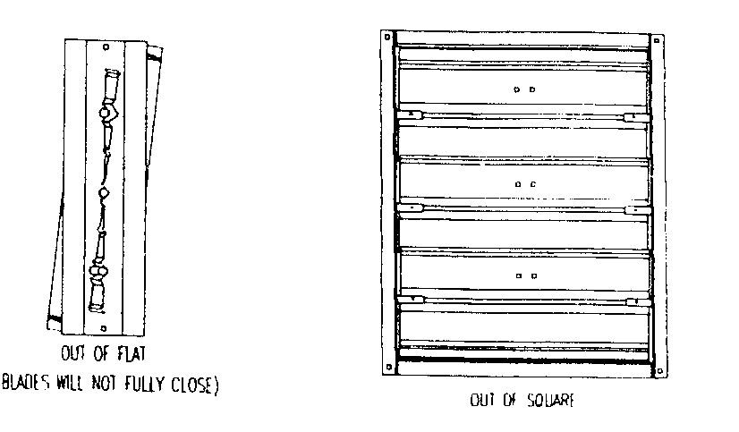  Installation Hints:  - Always observe and follow instructions on label affixed to damper.  - Before installation, ensure that damper is not damaged and blades operate freely.  - Allow sufficient space at side of damper for actuator mounting and min. 200 mm at front and back of damper for unimpeded blade rotation.  - Install damper ‘square and flat’ as per warning above. Carry out final field adjustment to blade linkages and tighten all screws, ensuring that all damper close tightly.  - Perform trial run of damper & actuator assembly, before attaching other end of duct work to damper.  OTHER DAMPER PRODUCTS  - Volume Control Dampers:  High performance Volume Damper, Ultra Low  Volume Control Damper, Min/Max Damper, Face  & Bypass Damper, Zone Damper, Non Return &  Barometric Damper.  - Fire Dampers:  Multi blade Fire Damper, Single Blade Fire  Damper, Circular Fire Damper, Volume-Fire  Damper, Ceiling Fire Damper, Curtain Fire  Damper.  - Subducts  - Damper Accessories

