Riley Air Control Systems Pty Ltd
CFDI Series

Ceiling Fire Dampers

One Hour Fire Integrity Rating

For Light-Weight Ceiling Construction

SPECIFICATION DATA

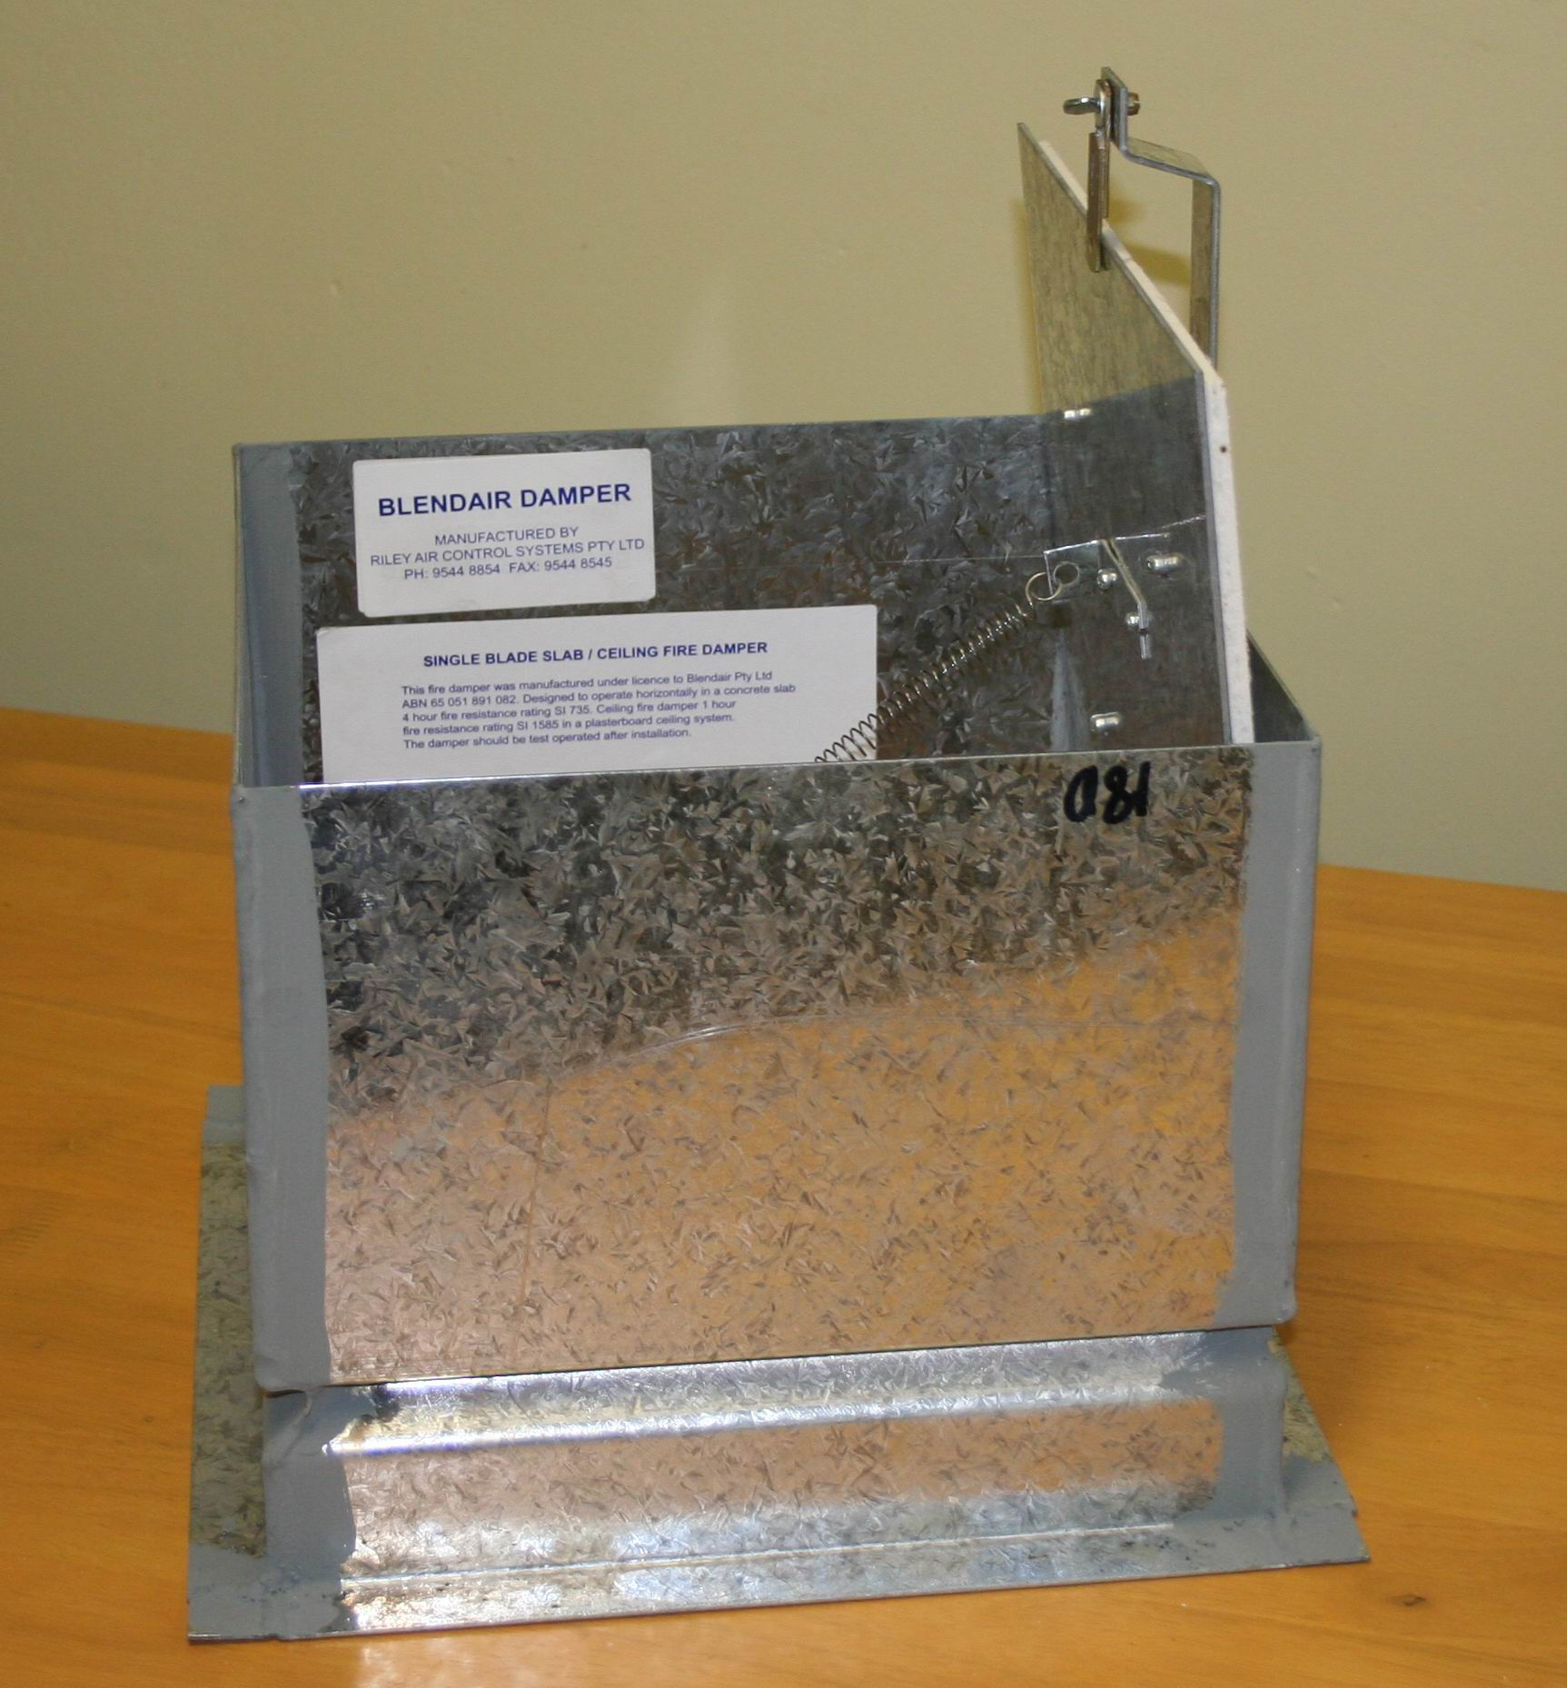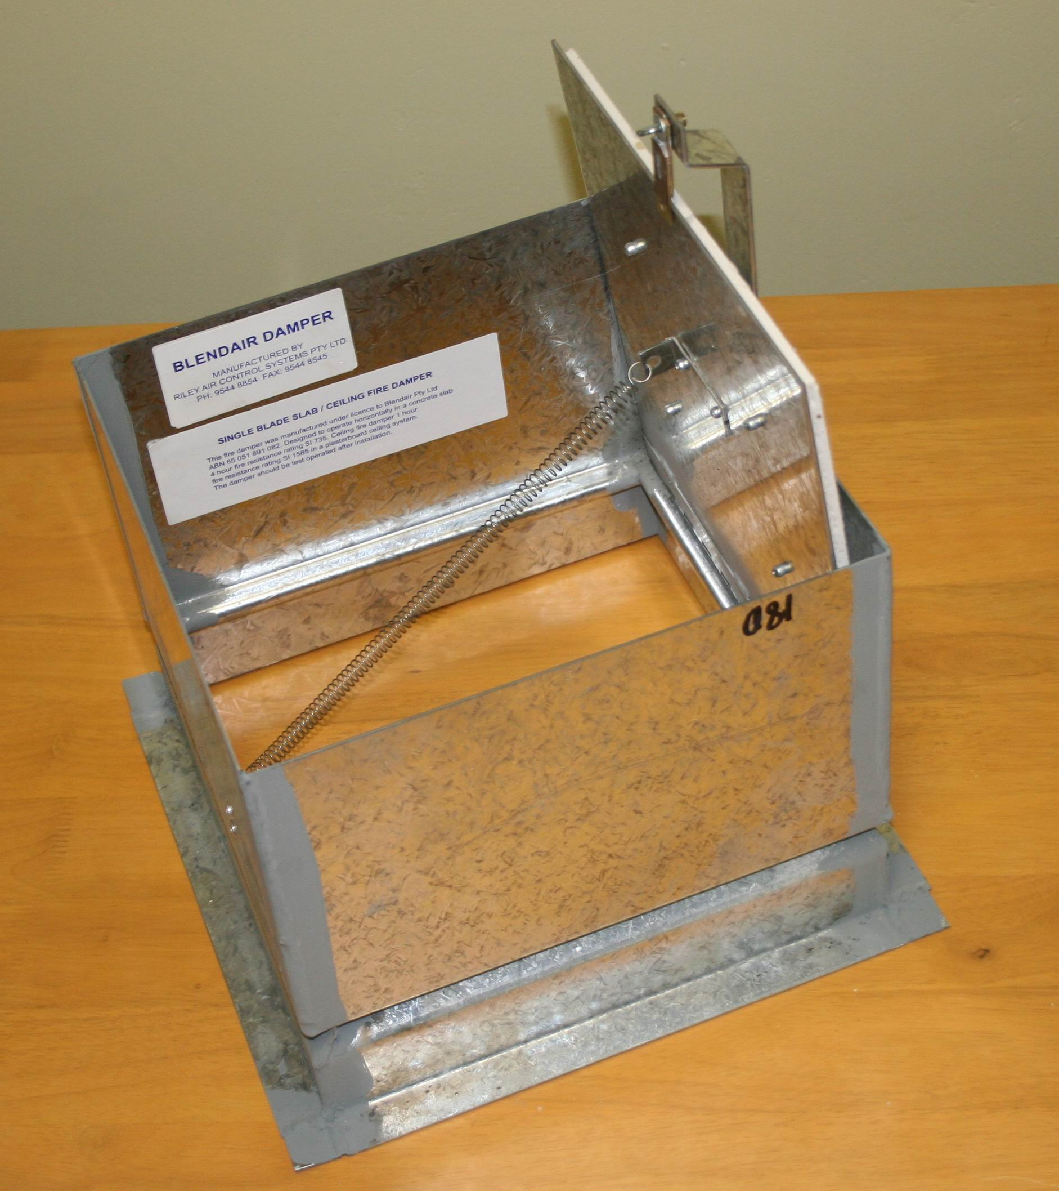

General

The Blendair CEILING Fire Damper Series BCFD is a simple and effective LIGHT-WEIGHT damper, designed to impede the spread of fire and or combustible products (eg. smoke) through ceiling openings to other fire compartments of an air-handling system.

This range of dampers find it’s application in shopping centre or general commercial building construction where ventilation, heating, cooling or air-conditioning systems require the installation of a fire damper in the plenum of the ceilings.

The design principle is based on an insulated, piano hinged, SINGLE BLADE that closes by gravity to form a tightly sealed barrier when a fusible thermal link breaks at a set temperature.

Blendair Single Blade CEILING Fire Dampers were tested as part of a 1 hour Gyprock ceiling assembly.

Features

- Simplicity in design

- Tight manufacturing tolerances

- Sturdy press-formed and fully welded frame construction

- Light weight damper easy to install

- Suitable for lightweight ceiling construction

- Adjustable mounting angles

- Heat protective shielding on blade

- Spring assisted closure

CFDI SINGLE BLADE CEILING FIRE DAMPER

DESCRIPTION & FUNCTION
The Blendair CEILING Fire Damper Series CFDI is a LIGHT-WEIGHT damper, designed to impede the spread of fire and or combustible products (eg. smoke) through ceilings openings to other fire compartments of an air-handling system. Its main application is in shopping centre or general commercial building construction where a ventilation, heating, cooling or air-conditioning systems requires the installation of a fire damper in the plenum of the ceilings. The design principle is based on a piano hinged, SINGLE BLADE that closes by gravity to form a tightly sealed barrier when a fusible thermal link breaks at a set temperature. The blade is covered with a fire resistant fibre sheet to minimise heat penetration through the damper and ceiling. The damper is securely attached to the duct system within the plenum of a light-weight ceiling construction. Single Blade Fire Dampers are certified by Standards Australia and meet AS 1682 and AS 1530 requirements.

MODELS
- CFDI: CEILING Fire Dampers for installation in light-weight ceiling construction for vertical air-flow with One (1) Hours Fire Integrity Rating

GUIDE SPECIFICATION (for the Engineer)
Fire Dampers installed shall be of design and construction as supplied by Blendair which meet the requirements of Australian Standards AS 1682 - Part 1 & 2 and AS 1530.

The damper frame shall be of press-formed and welded galvanised steel construction to minimise distortion during transit and to maintain squareness during installation. The galvanised steel blade shall be pivoted by special S/S piano hinge. The damper must guarantee accuracy and consistent closing operation.

DAMPER SIZING SPECIFICATIONS
Modules are supplied in the following standard sizes:
Damper Sizes: from 150mm x 150mm (min)
to 450mm x 450mm (max)
Size Increment: 50mm
Multi Modules: not available
Note: When specifying damper sizes (width and height),
quote internal duct dimensions.

SHIPPING WEIGHTS (Kg)
Height  (mm) | 150 | 200 | Width  300 |  | (mm)  400 | 450
150 | 4 | 5 |  | 8 | 10 | 11
200 | 5 | 7 |  | 9 | 11 | 12
250 | 6 | 8 |  | 10 | 13 | 14
300 | 8 | 9 |  | 12 | 14 | 16
350 | 9 | 10 |  | 13 | 16 | 18
400 | 10 | 11 |  | 14 | 18 | 19
450 | 11 | 12 |  | 16 | 19 | 21

SPECIFICATIONS - Construction
Materials & Finishes:
- Damper frame, blades and mounting angles made of zinc-coated ("galvanised") steel sheet, complying with AS 1397 with a coating class not less than Z275.
- Damage to the zinc-coating, eg. through welding, is remedied by appropriate cleaning method and application of special 'galvanising' paint.
- Stainless steel version available as OPTION.

Damper Frame:
Press-formed 1.6 mm galvanised steel, fully welded at all four corners, with 6x12 mm rounded slots punched into casing to allow for variations in ceiling thickness.


Damper Blade:
Flat 1.6 mm (nominal) galvanised steel sheet, with 8 mm fire rated insulating sheet riveted to blade.

DAMPER ORDERING SPECIFICATION
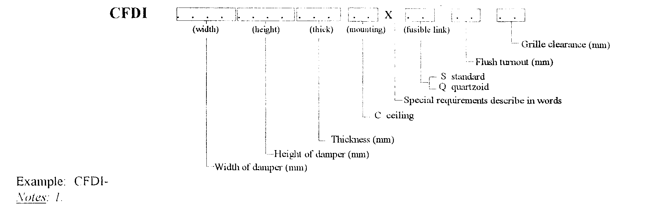

CFDI SINGLE BLADE CEILING FIRE DAMPER

Blade Orientation/Location:
Vertical:
Blade is off-centre pivoted and held at top of damper by thermal fire link assembly. Blade closes by gravity, initiated by breaking of thermal fire link.

Mounting Angles:
Roll-formed 2.0 mm or 2.5 mm 'right-angle' brackets with 6x12 mm rounded slots at 150 mm pitch to allow for variations in ceiling thickness.

Blade Hinge:
Blade is pivoted on special stainless steel hinge spot welded to blade and damper casing.

Blade Close-Off Spring:
Stainless steel tnesion spring is attached to damper blade and cassing to assist closing of blade.

Blade Retainer Clip:
1.0 mm spring bronze material - press-formed clip retains blade in closed position, allowing release from both ends of damper.

Thermal Fire Link:
The thermal fire link - a 'once only' used link -
- Standard: Fusible Solder Link (70 degree C)
- Optional: Quartzoid Bulb (68 degree C)
Note: Thermal fire link assembly includes interlocked stainless steel rings and bracket which is attached to a tag for duct attachment.

Access to Thermal Fire Link:
From “off air” side of damper only - for purposes of blade re-setting or re-fitting of Thermal Fire Link.

Mounting Hardware:
Zinc plated 1/4 inch cup head bolts and nut for each set of slotted mounting holes in frame & mounting angles (if required).

SPECIFICATIONS - Technical
Operation:
Damper closing is initiated by the breaking of the thermal fire link, when temperature in the air stream reaches rated thermal limit.

For wall mounted dampers the horizontally held blade will consequently close by gravity and form a tight barrier, impeding the spread of fire and/or combustible products to other compartments of the air-handling system.

For floor mounted dampers, the vertically held blade is fitted with a tension spring to assist the blade closing.

Damper Closing Temperature:
- Standard 'Solder' Fire Link: 70 degree C (nominal)
- Quartzoid Bulb: 68 degree C (nominal)
- Special thermal links or other actuation devices could be fitted by installers, providing they comply with Standards.

Maximum Air Velocity:
IMPORTANT!
It should be avoided to install Fire Dampers near the supply fan which may cause blade flutter and thus excessive wear of blade bearings.

Recommended Air Velocity:
10.5 m/s (reasonable average)
15.0 m/s (maximum)
Note: Above values are recommendations from industry survey carried out by CSIRO.

Air-Flow Orientation:
Orientation of damper installation should be as per recommended air-flow direction (label affixed to damper frame), so that damper closes with assistance of the air-flow.

SPARE PARTS
Model No. | Description | Qty/Set
BFD-01 | Fusible Solder Link (71 degree C) | 5
BFD-02 | Quartzoid Bulb (68 degree C) | 1
BFD-03 | Flange Mtg Kit (Bolt & Nut) | 50
BFD-27 | Electro Thermal Link  (Special, refer to Factory) | 1

Standards Approval Listing
CFDI Single Blade CEILING Fire Dampers have passed the tests to meet the Leakage and Fire Integrity requirements of AS 1530-Part 4 and AS 1682-Part 1, with the dampers exposed to ~ 1100 degree Celsius for a period of one (1) hour. Tests were carried out in conjunction with CSR at the CSIRO Testing Station.

Copies of SA Certificates may be supplied on request.

CFDI SINGLE BLADE CEILING FIRE DAMPER

INSTALLATION
IMPORTANT: The installation of Fire Dampers must comply with the requirements of AS 1682, Part 2. Deviation from any Clause of the Standards must be approved by a Regulatory Authority!

Basic Regulations:
1. Dampers shall be installed in the fully open position only! No intermediate blade position is allowed!
2. Damper frame (casing) must fully penetrate the ceiling opening.
3. Clearance between opening and damper frame must be such to allow adequate of insulating material, PLUS expansion factor for fire situation.
Recommended clearance formulae:
5 mm + ½% of linear length dimension (width/height)
4. The clearance space between the damper and the penetrated wall opening must be fully packed with approved insulating material to prevent free flow of combustible materials (eg. smoke). Material must maintain fire integrity up to 1000 degree C.
5. Mounting Flanges must cover the clearance (2x clearance). Contractor may have to fit larger flanges if clearance exceeds recommended sizes.
6. Install damper to allow blade to close by gravity or spring assist.

Other Installation Hints:
1. Remove set of mounting flanges from damper casing.
2. Insert damper into ceiling opening.
3. Pack clearance space between damper casing and ceiling opening with insulating material to meet above requirements.
4. Re-fit mounting flanges, nuts & bolts to damper and tighten, ensuring that flanges are butting tight against the ceiling and that damper is fitted squarely.
5. Ensure that damper closure is not impeded by any obstruction, incorrect installation (eg. twisted, out of square), damage to damper or contamination to blade bearings (eg. building dust).
6. Check proper closing operation.
7. When fitting duct ensure that appropriate damper sleeve connections are used to allow proper duct 'breakaway' in a fire situation (refer AS 1682, part 2 - Appendix B: Examples).

OTHER DAMPER PRODUCTS
- Fire Dampers:
Multi-Blade Fire Damper, Single Blade Fire Damper, Curtain Fire Damper, Circular Fire Damper, 'Volume’-Fire Damper
- Volume Control Dampers:
Low Leakage Volume Damper (standard), Ultra Low Leakage Volume Damper, High Performance Volume Damper, Min/Max Damper, Face & Bypass Damper, Zone Damper, Non-Return & Barometric Damper
- Sub Ducts
- Damper Actuators & Accessories:

Head Office: Riley Air Control Systems Pty. Ltd.
3/78-80 Belingara Road
Miranda
Phone: (02) 9544 8854
Fax : (02) 9544 8545
Email: info@rileyair.com.au
A.B.N. 80 003 437 732

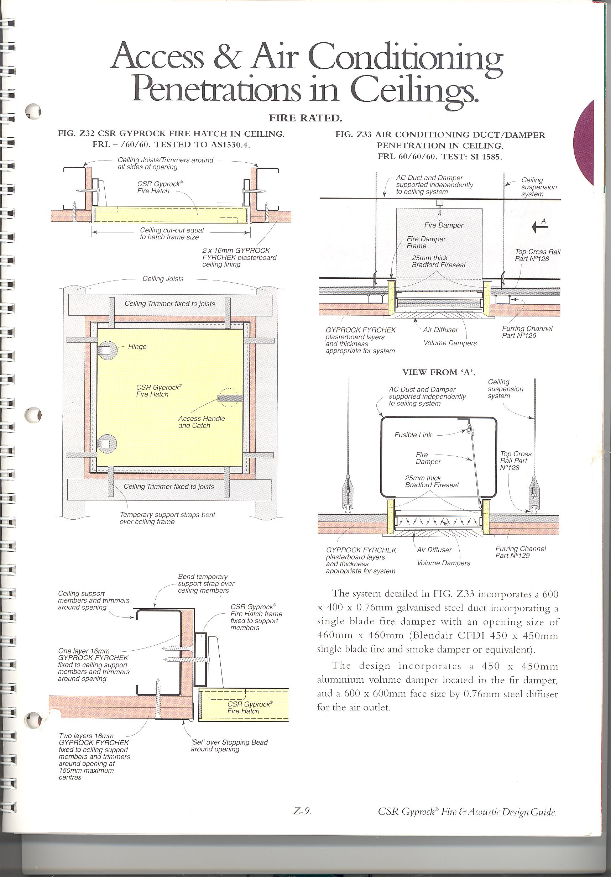
Head Office: Riley Air Control Systems Pty. Ltd.
3/78-80 Belingara Road
Miranda
Phone: (02) 9544 8854
Fax : (02) 9544 8545
Email: info@rileyair.com.au

